


Data Compliance Test (DCT)
Test Cases for
Dispensing Record

<HCP Name>

Table of Contents
1 Testing Instructions to HCPs 3
1.1 Self-Service Testing Phase 3
1.2 Final Testing Phase 3
1.3 Preparation DCT Test Report 4
1.4 Notes for HCP on Dispensing test cases 4
2 Test Case Details 5
RXD-LV3-001 [FOR LEVELS 3.1 AND 3.2 DATA UPLOAD ONLY] 5
RXD-LV3-002 [FOR LEVELS 3.1 AND 3.2 DATA UPLOAD ONLY] 15
RXD-LV2-001 [FOR LEVEL 2 DATA UPLOAD ONLY] 22
RXD-LV2-002 [FOR LEVEL 2 DATA UPLOAD ONLY] 26
3 Appendix – Sample Messages 30
4 Appendix – Testing HCP and HCRs Information 32
5 Appendix – Sample Results in eHR Viewer (EVE) 33
6 Appendix – Actual Data Values (Sample) 37

Testing Instructions to HCPs

Self-Service Testing Phase
- After development of the data upload programmes, you can use the Self-Service test accounts and test HCRs provided by eHealth for connection to the eHealth testing environment and proceed with the self-service testing.
- You can proceed with the Self-service test at your own pace by following this Self-Service Testing Guide and using the test cases provided in section 2.
- You can verify the correctness and completeness of the data upload by:
- checking the interface files / messages generated in your system against the sample expected results of interface files /messages for all test cases as provided;
- checking the results on eHR Viewer (EVE) by logging into the testing eHealth with the provided test account; and
- checking the upload status through Process Summary and Exception Report in eHR Inbox by logging into the testing eHealth.
- For data fields requiring eHR Codex values, you can refer the Code Sets provided with the Self-Service Kit.
- For details of technical requirements of the data interface files, please refer to the ‘Quick Guide for Dispensing Data Upload.docx’.
- You are required to perform the test cases that are relevant to the data compliance level (Level 2, 3.1 or 3.2) supported by your clinic.
- You are required to perform the first batch of data upload by Data Materialization (DM) mode. DM mode is denoted in the interface by a fixed value BL-M in HL7 OBX.4
- You should use Incremental Load (INC) mode for the second batch of data upload to update the previously uploaded records. INC mode is denoted in the interface by a fixed value BL in HL7 OBX.4.
- Since the DM mode would replace the corresponding records previously uploaded to eHealth, you may repeat your testing unlimited number of times by uploading the first batch by DM mode.
- It should be noted that the data field “Record Key” can be unique at dispensing order level or drug item level. If “Record Key” is unique in dispensing order level, same record key would correspond to each drug item in a dispensing order. Otherwise, each drug item can be uploaded by separate “Record Key”.
- When all required test cases can be completed smoothly and correctly in this phase, you can proceed to the Final Testing Phase and submit production environment setup form to eHR DCT Support for preparation.

Final Testing Phase
- You can start the Final Testing Phase once all test cases in the Self-Service Testing phase are passed.
- You should start Final Test by executing the test cases provided in section 2 with Final Testing HCRs provided by eHR DCT Support.
- You can verify the correctness and completeness of testing results by checking results in eHR Viewer (EVE) and the upload status through Process Summary and Exception Report in eHR Inbox.
- For Dispensing DCT test cases, there are TWO batches of data files / transactions to be uploaded to the testing eHealth. The required records must be correctly uploaded from these 2 consecutive batches respectively.
- The Final Test will be considered PASSED if all the following criteria are met:
- The TWO batches of test data files are uploaded consecutively in the correct sequence. The second batch of data files/transactions must be submitted after completion of processing of the first batch by eHealth
- No additional data files / transactions are uploaded in between or after the uploads of the above two batches of data files / transactions to amend any records.
- No exception records are reported from the uploads.
- No manual interventions have been made to the data files / transactions.
- If the Final Test failed, you can re-attempt the Self-Service Test and Final Test until a successful run can be completed.

Preparation DCT Test Report
- Once you have successfully passed the Final Test based on the above criteria, you should complete this document by attaching the below items to this document at the appropriate space provided:
  - Actual data files uploaded
  - Screen-shot of each test case
- You are required to submit this completed ‘DCT Test Cases’ document to eHR DCT Support for further processing. eHR DCT Support will provide feedback within 10 working days.

Notes for HCP on Dispensing test cases
- Please use different drugs and different dose forms for each test case so that different dose instructions can be tested.
- If the provided test case or part of the case cannot fit your clinic’s current practices, please state the reason for omitting the test case.
- It is suggested that the same drugs used in the test cases are created in the EMR testing system’s drug database with the same local descriptions even if the corresponding drug(s) are not used / stocked by your clinic to allow easy comparison of your test results versus the provided results. Alternatively, similar drugs with similar dose forms can be substituted in the test cases but manual efforts may be required to compare your test results with the provided results for test results verification.
- For level 2 and 3 data, please capture the screen for eHR Viewer (EVE). For level 3 data, please also test and capture mouse over results on the screen.
- To ensure accurate communication with the patient and other health care professionals to avoid misunderstanding, HCP must construct the dose instruction in a sentence containing the following information of the prescribed /dispensed medications: 1. route of administration, 2. dose, 3. frequency, 4. duration of treatment or treatment start and end date.
- Beside eHR Viewer (EVE), the dispensing record will also be displayed in the eHealth app for patients. It is recommended that the dose instruction should be understandable by lay persons similar to those shown on drug labels for patients.

Test Case Details
- RXD-LV3-001 and RXD-LV3-002 : Only applicable for testing level 3.1 or 3.2 data upload
- RXD-LV2-001 and RXD-LV2-002 : Only applicable for testing level 2 data upload
- Please complete and collect the upload results for RXD-xxx-001 before proceeding to RXD-xxx-002.
1 | Test Case ID | RXD-LV3-001 [FOR LEVELS 3.1 AND 3.2 DATA UPLOAD ONLY]
 | Function Description | HCP received sharing consents from testing HCRs, then perform the first data upload of HCRs’ clinical records to eHealth by DM Mode for Level 3 (3.1 or 3.2) data.
 | Subsequent case of | N/A
 | Testing Assumption | - HCR1-HCR7 have already given sharing consents to the HCP.  - The eMR system (EMRS) contains dispensing records of these HCRs and will upload all the dispensing records of <HCR1> - <HCR7> to eHealth in Batch 1 data files created by DM mode.
 | Test Actions | HCP creates below dispensing records in the eMR system:
 | Test Actions | 1a | Case scenario: Dispense an oral tablet for <HCR1> in the EMRS as follows:  - Dispensing datetime = 01-Mar-2022 10:00:00  - Drug local terminology = PARACETAMOL TABLET 500MG (ORAL)  - Route of administration = ORAL  - Dosage = 1 TABLET(S)  - Dose frequency = TDS  - Dispensing duration = 5 Days  - Total quantity dispensed = 15 TABLET(S)  - PRN = Yes  - Remarks = “For Fever or Pain” (only applicable if HCP would like to upload dispensing remarks)  == Actual data values (Refer to “Appendix - Actual Data Values (Sample)” for details)  Expected result:  - The local drug description and local dose instruction in sentence will be shown in the eHR Viewer (EVE).  - Mouse over the local drug description will show the RT drug description.  - Dispensing records based on HCP elected recognized terminology will be generated in Batch 1 Data File with the following details. (Test results should be compared with provided results <DF and DF_INS message files> as attached be Appendix 3 Sample Messages)  Applicable to both Level 3.1, 3.2 data upload  - Dispensing datetime = 01-Mar-2022 10:00:00  - Dispensed drug – recognised terminology name = HKCTT / RPP  - Dispensed drug identifier – recognised terminology = 6000095 / 61273  - Dispensed drug description – recognised terminology = paracetamol oral tablet 500 mg / PANAMOL TAB 500MG  - Dispensed drug description – local terminology = PARACETAMOL TABLET 500MG (ORAL)  - Dispensing remarks = For Fever or Pain  - Dispensing institution local name = [source system provided]  - Dispensed dose instruction (combined text) = [source system provided]  Additional fields applicable to Level 3.2 data upload only  - Dispensed drug dose value = 1  - Dispensed drug dose unit code = 7700245  - Dispensed drug dose unit description = tablet  - Dispensed drug dose unit local description = TABLET(S)  - Dispensed drug frequency code = 7703160  - Dispensed drug frequency description = three times daily  - Dispensed drug frequency local description = TDS  - Dispensed drug PRN indicator = Y  - Dispensed route of medication administration code = 7700046  - Dispensed route of medication administration description = oral  - Dispensed route of medication administration local description = ORAL  - Dispensed drug duration value = 5  - Dispensed drug duration unit code = 7703285  - Dispensed drug duration unit description = day  - Dispensed drug duration unit local description = Days  - Dispensed drug quantity value = 15  - Dispensed drug quantity unit code = 7700245  - Dispensed drug quantity unit description = tablet  - Dispensed drug quantity unit local description = TABLET(S)
 | Test Actions | 1b | Case scenario: Dispense an eye drop for <HCR2> in the EMRS as follows:  - Dispensing datetime = 01-Mar-2022 10:00:00  - Drug local terminology = COMBIGAN (OR EQUIV) EYE DROPS 5ML (OPHTHALMIC)  - Route of administration = EYES  - Site of administration = BOTH EYES  - Dosage = 1 DROP(S)  - Dose frequency = BD  - Dispensing duration = 5 Days  - Total quantity dispensed = 1 BOTTLE(S)  == Actual data values (Refer to “Appendix - Actual Data Values (Sample)” for details)  Expected result:  - The local drug description and local dose instruction in sentence will be shown in the eHR Viewer (EVE).  - Mouse over the local drug description will show the RT drug description.  - Dispensing records based on HCP elected recognized terminology will be generated in Batch 1 Data File with the following details. (Test results should be compared with provided results <DF and DF_INS message files> as attached be Appendix 3 Sample Messages)  Applicable to both Level 3.1, 3.2 data upload  - Dispensing date/time = 01-Mar-2022 10:00:00  - Dispensed drug - recognised terminology name = HKCTT / RPP  - Dispensed drug identifier - recognised terminology = 6023887 / 56799  - Dispensed drug description - recognised terminology = brimonidine tartrate 0.2 % + timolol (as maleate) 0.5 % eye drops / COMBIGAN EYE DROPS  - Dispensed drug description - local terminology = COMBIGAN (OR EQUIV) EYE DROPS 5ML (OPHTHALMIC)  - Dispensing institution local name = [source system provided]  - Dispensed dose instruction (combined text) = [source system provided]  Additional fields applicable to Level 3.2 data upload only  - Dispensed drug dose value = 1  - Dispensed drug dose unit code = 7700306  - Dispensed drug dose unit description = drop  - Dispensed drug dose unit local description = DROP(S)  - Dispensed drug frequency code = 7703156  - Dispensed drug frequency description = twice daily  - Dispensed drug frequency local description = BD  - Dispensed route of medication administration code = 7700009  - Dispensed route of medication administration description = eye  - Dispensed route of medication administration local description = EYES  - Dispensed site of medication administration code = 8003595  - Dispensed site of medication administration description = Both eyes  - Dispensed site of medication administration local description = BOTH EYES  - Dispensed drug duration value = 5  - Dispensed drug duration unit code = 7703285  - Dispensed drug duration unit description = day  - Dispensed drug duration unit local description = Days  - Dispensed drug quantity value = 1  - Dispensed drug quantity unit code = 7700288  - Dispensed drug quantity unit description = bottle  - Dispensed drug quantity unit local description = BOTTLE(S)
 | Test Actions | 1c | Case scenario: Dispense an oral liquid for <HCR3> in the EMRS as follows:  - Dispensing datetime = 01-Mar-2022 10:00:00  - Drug local terminology = LACTULOSE LIQUID (ORAL)  - Route of administration = ORAL  - Dosage = 10 MILLILITRE(S)  - Dose frequency = BD  - Dispensing duration = 1 Weeks  - Total quantity dispensed = 120 MILLILITRE(S)  == Actual data values (Refer to “Appendix - Actual Data Values (Sample)” for details)  Expected result:  - The local drug description and local dose instruction in sentence will be shown in the eHR Viewer (EVE).  - No mouse over the local drug description will show the RT drug description.  - The record will be shown in the regrade report.  - Dispensing records based on HCP elected recognized terminology will be generated in Batch 1 Data File with the following details. (Test results should be compared with provided results <DF and DF_INS message files> as attached be Appendix 3 Sample Messages)  Applicable to both Level 3.1, 3.2 data upload  - Dispensing date/time = 01-Mar-2022 10:00:00  - Dispensed drug – recognised terminology name = HKCTT / RPP  - Dispensed drug identifier – recognised terminology = 6008915 / 32072  - Dispensed drug description – recognised terminology = LACTULOSE LIQUID (ORAL)  - Dispensed drug description – local terminology = LACTULOSE LIQUID (ORAL)  - Dispensing institution local name = [source system provided]  - Dispensed dose instruction (combined text) = [source system provided]  Additional fields applicable to Level 3.2 data upload only  - Dispensed drug dose value = 10  - Dispensed drug dose unit code = 7700387  - Dispensed drug dose unit description = mL  - Dispensed drug dose unit local description = MILLILITRE(S)  - Dispensed drug frequency code = 7703156  - Dispensed drug frequency description = twice daily  - Dispensed drug frequency local description = BD  - Dispensed route of medication administration code = 7700046  - Dispensed route of medication administration description = oral  - Dispensed route of medication administration local description = ORAL  - Dispensed drug duration value = 1  - Dispensed drug duration unit code = 7703286  - Dispensed drug duration unit description = week  - Dispensed drug duration unit local description = Weeks  - Dispensed drug quantity value = 120  - Dispensed drug quantity unit code = 7700387  - Dispensed drug quantity unit description = mL  - Dispensed drug quantity unit local description = MILLILITRE(S)  Remark: Record will show in “Re-grade Report” as Dispensed drug description – recognised terminology not matched the Dispensed drug identifier – recognised terminology in IAMS.
 | Test Actions | 1d | Case scenario: Dispense an inhaler in “free text” for <HCR4> in the EMRS as follows:  - Dispensing datetime = 01-Mar-2022 10:00:00  - Drug local terminology = BECLOFORTE 250 mcg “Free text”  - Route of administration = RESPIRATORY TRACT  - Dosage = 2 PUFF(S)  - Dose frequency = BD  - Dispensing duration = 1 Weeks  - Total quantity dispensed = 1 NUMBER(S)  == Actual data values (Refer to “Appendix - Actual Data Values (Sample)” for details)  Expected result:  - The local drug description and local dose instruction in sentence will be shown in the eHR Viewer (EVE).  - No mouse over the local drug description will show the RT drug description.  - The record will be shown in the regrade report.  - Dispensing records based on HCP elected recognized terminology will be generated in Batch 1 Data File with the following details. (Test results should be compared with provided results <DF and DF_INS message files> as attached be Appendix 3 Sample Messages)  Applicable to both Level 3.1, 3.2 data upload  - Dispensing datetime = 01-Mar-2022 10:00:00  - Dispensed drug – recognised terminology name =  - Dispensed drug identifier – recognised terminology =  - Dispensed drug description – recognised terminology =  - Dispensed drug description – local terminology = BECLOFORTE 250 mcg “Free text”  - Dispensing institution local name = [source system provided]  - Dispensed dose instruction (combined text) = [source system provided]  Additional fields applicable to Level 3.2 data upload only  - Dispensed drug dose value = 2  - Dispensed drug dose unit code = 7700273  - Dispensed drug dose unit description = actuation  - Dispensed drug dose unit local description = PUFF(S)  - Dispensed drug frequency code = 7703156  - Dispensed drug frequency description = twice daily  - Dispensed drug frequency local description = BD  - Dispensed route of medication administration code = 7703693  - Dispensed route of medication administration description = respiratory tract  - Dispensed route of medication administration local description = RESPIRATORY TRACT  - Dispensed drug duration value = 1  - Dispensed drug duration unit code = 7703286  - Dispensed drug duration unit description = week  - Dispensed drug duration unit local description = Weeks  - Dispensed drug quantity value = 1  - Dispensed drug quantity unit code =7703702  - Dispensed drug quantity unit description = number  - Dispensed drug quantity unit local description = NUMBER(S)  Remark: Record will show in “Re-grade Report” as “Dispensing: Data Compliance Level Regrade Report”.
 | Test Actions | 1e | Case scenario: Dispense an injection for <HCR5> and then DELETE the record immediately in the EMRS as follows:  - Dispensing datetime = 01-Mar-2022 10:00:00  - Drug local terminology = CEFTRIAXONE DISODIUM IM INJECTION 250MG (INTRAMUSCULAR)  - Route of administration = INTRAMUSCULARLY  - Dosage = 250 MILLIGRAM(S)  - Dose frequency = DAILY  - Dispensing duration = 1 Weeks  - Total quantity dispensed = 7 VIAL(S)  == Actual data values (Refer to “Appendix - Actual Data Values (Sample)” for details)  Expected result:  - No record will be found in the eHR Viewer (EVE).  - The record data will not be included in DF and DF_INS message files
 | Test Actions | 1f | Case scenario: Dispense an injection for <HCR6> in the EMRS with core regimen components mapped but invalid route codex as follows:  - Dispensing datetime = 01-Mar-2022 10:00:00  - Drug local terminology = INSULIN NEUTRAL HUMAN (ACTRAPID) PENFILL 100U/ML 3ML (SUBCUTANEOUS)  - Route of administration = SUBCUTANEOUSLY  - Dosage = 10 UNIT(S)  - Dose frequency = TDS  - Dispensing duration = 1 Weeks  - Total quantity dispensed = 1 NUMBER(S)  == Actual data values (Refer to “Appendix - Actual Data Values (Sample)” for details)  Expected result:  - The local drug description and local dose instruction in sentence will be shown in the eHR Viewer (EVE).  - Mouse over the local drug description will show the RT drug description.  - The record will be shown in the regrade report.  - Dispensing records based on HCP elected recognized terminology will be generated in Batch 1 Data File with the following details. (Test results should be compared with provided results <DF and DF_INS message files> as attached be Appendix 3 Sample Messages)  Applicable to both Level 3.1, 3.2 data upload  - Dispensing datetime = 01-Mar-2022 10:00:00  - Dispensed drug – recognised terminology name = HKCTT / RPP  - Dispensed drug identifier – recognised terminology = 6114506 / 25781  - Dispensed drug description – recognised terminology = Actrapid (insulin soluble human) parenteral solution for injection (cartridge) 100 international unit / mL (3 mL) / ACTRAPID HM PENFILL NEUTRAL INJ 100IU/ML  - Dispensed drug description – local terminology = INSULIN NEUTRAL HUMAN (ACTRAPID) PENFILL 100U/ML 3ML (SUBCUTANEOUS)  - Dispensing institution local name = [source system provided]  - Dispensed dose instruction (combined text) = [source system provided]  Additional fields applicable to Level 3.2 data upload only – (core regimen components mapped but invalid route codex)  - Dispensed drug dose value = 10  - Dispensed drug dose unit code = 7700253  - Dispensed drug dose unit description = unit  - Dispensed drug dose unit local description = UNIT(S)  - Dispensed drug frequency code = 7703160  - Dispensed drug frequency description = three times daily  - Dispensed drug frequency local description = TDS  - Dispensed route of medication administration code = 7700058  - Dispensed route of medication administration description = SUBCUTANEOUSLY  - Dispensed route of medication administration local description = SUBCUTANEOUSLY  - Dispensed drug duration value = 1  - Dispensed drug duration unit code = 7703286  - Dispensed drug duration unit description = week  - Dispensed drug duration unit local description = Weeks  - Dispensed drug quantity value = 1  - Dispensed drug quantity unit code =7703702  - Dispensed drug quantity unit description = number  - Dispensed drug quantity unit local description = NUMBER(S)  Remark: Record will show in “Re-grade Report” as “Dispensing: Unmatched Codex Description”.
 |  | 1g | Case scenario: Dispense a cream for <HCR7> in the EMRS with core regimen components mapped + missing non-core components as follows:  - Dispensing datetime = 01-Mar-2022 10:00:00  - Drug local terminology = FLUOCINOLONE 0.005% 5G (TOPICAL)  - Route of administration = SKIN  - Dose frequency = DAILY  - Dispensing duration = 1 Weeks  - Total quantity dispensed = 1 TUBE(S)  == Actual data values (Refer to “Appendix - Actual Data Values (Sample)” for details)  Expected result:  - The local drug description and local dose instruction in sentence will be shown in the eHR Viewer (EVE).  - Mouse over the local drug description will show the RT drug description.  - Dispensing records based on HCP elected recognized terminology will be generated in Batch 1 Data File with the following details. (Test results should be compared with provided results <DF and DF_INS message files> as attached be Appendix 3 Sample Messages)  Applicable to both Level 3.1, 3.2 data upload  - Dispensing datetime = 01-Mar-2022 10:00:00  - Dispensed drug – recognised terminology name = HKCTT / RPP  - Dispensed drug identifier – recognised terminology = 6053270 / 46755  - Dispensed drug description – recognised terminology = fluocinolone acetonide topical cream 0.005 % / FLUOCINOLONE CREAM 0.005% (VIDA)  - Dispensed drug description – local terminology = FLUOCINOLONE 0.005% 5G (TOPICAL)  - Dispensing institution local name = [source system provided]  - Dispensed dose instruction (combined text) = [source system provided]  Additional fields applicable to Level 3.2 data upload only – (core regimen components mapped + missing non-core components [no dose value and no dose unit])  - Dispensed drug dose value = null  - Dispensed drug dose unit code = null  - Dispensed drug dose unit description = null  - Dispensed drug dose unit local description = null  - Dispensed drug frequency code = 7703152  - Dispensed drug frequency description = once daily  - Dispensed drug frequency local description = DAILY  - Dispensed route of medication administration code = 7700061  - Dispensed route of medication administration description = topical  - Dispensed route of medication administration local description = SKIN  - Dispensed drug duration value = 1  - Dispensed drug duration unit code = 7703286  - Dispensed drug duration unit description = week  - Dispensed drug duration unit local description = Weeks  - Dispensed drug quantity value = 1  - Dispensed drug quantity unit code = 7700250  - Dispensed drug quantity unit description = tube  - Dispensed drug quantity unit local description = TUBE(S)
 | Expected eMR System Behavior | - HCP’s eMR system will upload Batch 1 data files with all dispensing records of created in 1a-1g (Level 3.1, 3.2 data) by DM mode.  - Batch 1 data files should include below files: <samples>  - Participant List (PL)  - Data File (DF)  - Dose Instruction Data File (DF_INS)  - HL7 message with signature  - Zip File (embedded PL, DFs and HL7 message files)  - Zip Control File (contains the filenames of PL, DFs and HL7 message)  - eMR system uploads Batch 1 data files (‘Zip File’ and ‘Zip Control File') to eHealth.  - HCP verifies the data upload status by reviewing the 'Process Summary Report' and 'Exception Report' in eHR Inbox.  - HCP verifies the completeness and correctness of data uploaded in eHR Viewer.
 | Results Verification | - HCP verifies the interface file contents and check if the uploaded records can be properly viewed in eHR Viewer (EVE). HCP must also review if the data batches uploaded can be processed successfully or rejected through ‘Process Summary’, ‘Exception Report’ and ‘Re-grade Report’ in eHR Inbox.
 | Actual Result  (Screenshot / Attachment) | Data Files Uploaded:  <Attached the Zip file and Control file; password to unzip the file>
 | Actual Result  (Screenshot / Attachment) | Attachment/Screenshot:  <Attached the screen shots of records uploaded in eHR Viewers>
 | Remark | <State your reasons/ justification for exemption with case number>
 | Testing Date | <Provided by HCP>
 | Verified By | <Provided by HCP>

2 | Test Case ID | RXD-LV3-002 [FOR LEVELS 3.1 AND 3.2 DATA UPLOAD ONLY]
 | Function Description | There are subsequent changes in HCRs’ clinical records in Batch 1 data upload. HCP uploads incremental changes to eHealth by INC Mode for Level 3 (3.1 or 3.2) data.
 | Subsequent cases of | RXD-LV3-001
 | Testing Assumption | HCP has already verified that Batch 1 data have been processed successfully with correct test results.
 | Test Actions | HCP updates dispensing records from Batch 1 in eMR system (EMRS) as follows:
 | Test Actions | 2a | Case scenario: Dispense an eye drop for <HCR1> in the EMRS as follows:  - Dispensing datetime = 01-Mar-2022 10:00:00  - Drug local terminology = COMBIGAN (OR EQUIV) EYE DROPS 5ML (OPHTHALMIC)  - Route of administration = EYES  - Site of administration = BOTH EYES  - Dosage = 1 DROP(S)  - Dose frequency = BD  - Dispensing duration = 5 Days  - Total quantity dispensed = 1 BOTTLE(S)  == Actual data values (Refer to “Appendix - Actual Data Values (Sample)” for details)  Expected result:  - The local drug description and local dose instruction in sentence will be shown in the eHR Viewer (EVE).  - Mouse over the local drug description will show the RT drug description.  - Dispensing records based on HCP elected recognized terminology will be generated in Batch 2 Data File with the following details. (Test results should be compared with provided results <DF and DF_INS message files> as attached be Appendix 3 Sample Messages)  Applicable to both Level 3.1, 3.2 data upload  - (Added) Dispensing datetime = 01-Mar-2022 12:00:00  - (Added) Dispensed drug – recognised terminology name = HKCTT / RPP  - (Added) Dispensed drug identifier – recognised terminology = 6023887/ 56799  - (Added) Dispensed drug description – recognised terminology = brimonidine tartrate 0.2 % + timolol (as maleate) 0.5 % eye drops/ COMBIGAN EYE DROPS  - (Added) Dispensed drug description – local terminology = COMBIGAN (OR EQUIV) EYE DROPS 5ML (OPHTHALMIC)  - (Added) Dispensing institution local name = [source system provided]  - (Added) Dispensed dose instruction (combined text) = [source system provided]  Additional fields applicable to Level 3.2 data upload only  - (Added) Dispensed drug dose value = 1  - (Added) Dispensed drug dose unit code = 7700306  - (Added) Dispensed drug dose unit description = drop  - (Added) Dispensed drug dose unit local description = DROP(S)  - (Added) Dispensed drug frequency code = 7703156  - (Added) Dispensed drug frequency description = twice daily  - (Added) Dispensed drug frequency local description = BD  - (Added) Dispensed route of medication administration code = 7700009  - (Added) Dispensed route of medication administration description = eye  - (Added) Dispensed route of medication administration local description = EYES  - (Added) Dispensed site of medication administration code = 8003595  - (Added) Dispensed site of medication administration description = Both eyes  - (Added) Dispensed site of medication administration local description = BOTH EYES  - (Added) Dispensed drug duration value = 5  - (Added) Dispensed drug duration unit code = 7703285  - (Added) Dispensed drug duration unit description = day  - (Added) Dispensed drug duration unit local description = Days  - (Added) Dispensed drug quantity value = 1  - (Added) Dispensed drug quantity unit code = 7700288  - (Added) Dispensed drug quantity unit description = bottle  - (Added) Dispensed drug quantity unit local description = BOTTLE(S)
 | Test Actions | 2b | Case scenario: Update the dosage and dispensing remarks of dispensing record in 1(a) for <HCR1> in the EMRS as follows:  - Dispensing datetime = 01-Mar-2022 10:00:00  - Drug local terminology = PARACETAMOL TABLET 500MG (ORAL)  - Route of administration = ORAL  - Dosage = 1 TABLET(S)  - (Updated) Dose frequency = BD  - Dispensing duration = 5 Days  - (Updated) Total quantity dispensed = 10 TABLET(S)  - PRN = Yes  - (Updated) Remarks = For Fever  == Actual data values (Refer to “Appendix - Actual Data Values (Sample)” for details)  Expected result:  - The local drug description, updated local dose instruction and dispensing remarks (if have) in sentence will be shown in the eHR Viewer (EVE).  - Mouse over the local drug description will show the RT drug description.  - Dispensing records based on HCP elected recognized terminology will be generated in Batch 2 Data File with the following details. (Test results should be compared with provided results <DF and DF_INS message files> as attached be Appendix 3 Sample Messages)  Applicable to both Level 3.1, 3.2 data upload  - Dispensing datetime = 01-Mar-2022 12:00:00  - Dispensed drug – recognised terminology name = HKCTT / RPP  - Dispensed drug identifier – recognised terminology = 6000095 / 61273  - Dispensed drug description – recognised terminology = paracetamol oral tablet 500 mg / PANAMOL TAB 500MG  - Dispensed drug description – local terminology = PARACETAMOL TABLET 500MG (ORAL)  - (Updated) Dispensing remarks = For Fever  - Dispensing institution local name = [source system provided]  - (Updated) Dispensed dose instruction (combined text) = [source system provided]  Additional fields applicable to Level 3.2 data upload only  - Dispensed drug dose value = 1  - Dispensed drug dose unit code = 7700245  - Dispensed drug dose unit description = tablet  - Dispensed drug dose unit local description = TABLET(S)  - (Updated) Dispensed drug frequency code = 7703156  - (Updated) Dispensed drug frequency description = twice daily  - (Updated) Dispensed drug frequency local description = BD  - Dispensed drug PRN indicator = Y  - Dispensed route of medication administration code = 7700046  - Dispensed route of medication administration description = oral  - Dispensed route of medication administration local description = ORAL  - Dispensed drug duration value = 5  - Dispensed drug duration unit code = 7703285  - Dispensed drug duration unit description = day  - Dispensed drug duration unit local description = Days  - (Updated) Dispensed drug quantity value = 10  - Dispensed drug quantity unit code = 7700245  - Dispensed drug quantity unit description = tablet  - Dispensed drug quantity unit local description = TABLET(S)
 | Test Actions | 2c | Case scenario: Discontinue dispensing record of 1(b) for <HCR2> in the EMRS as follows:  - Dispensing datetime = 01-Mar-2022 10:00:00  - Drug local terminology = COMBIGAN (OR EQUIV) EYE DROPS 5ML (OPHTHALMIC)  - Route of administration = EYES  - Site of administration = BOTH EYES  - Dosage = 1 DROP(S)  - Dose frequency = BD  - Dispensing duration = 5 Days  - Total quantity dispensed = 1 BOTTLE(S)  - (Added) Discontinuation information = Drug regimen adjustment  - (Added) Discontinuing institution identifier = [source system provided]  - (Added) Discontinuing institution long name = [source system provided]  - (Added) Discontinuing institution local name = [source system provided]  - (Added) Date of discontinuation = [Current date/time]  - (Added) Discontinuing Prescriber’s English full name = Dr Chan Tai Man  == Actual data values (Refer to “Appendix - Actual Data Values (Sample)” for details)  Expected result:  - The previous record will have strikethrough in the eHR Viewer (EVE).  - The discontinuation information will be shown under the previous record.  - Dispensing records based on HCP elected recognized terminology will be generated in Batch 2 Data File with the following details. (Test results should be compared with provided results <DF and DF_INS message files> as attached be Appendix 3 Sample Messages)  Applicable to both Level 3.1, 3.2 data upload  - Dispensing date/time = 01-Mar-2022 10:00:00  - Dispensed drug - recognised terminology name = HKCTT / RPP  - Dispensed drug identifier - recognised terminology = 6023887 / 56799  - Dispensed drug description - recognised terminology = brimonidine tartrate 0.2 % + timolol (as maleate) 0.5 % eye drops / COMBIGAN EYE DROPS  - Dispensed drug description - local terminology = COMBIGAN (OR EQUIV) EYE DROPS 5ML (OPHTHALMIC)  - Dispensing institution local name = [source system provided]  - Dispensed dose instruction (combined text) = [source system provided]  - (Added) Dispensed medication discontinuation status = Y  - (Added) Dispensed medication discontinuation information = Drug regimen adjustment  - (Added) Dispensed medication discontinuing institution identifier = [source system provided]  - (Added) Dispensed medication discontinuing institution long name = [source system provided]  - (Added) Dispensed medication discontinuing institution local name = [source system provided]  - (Added) Date of dispensed medication discontinuation = [Current date/time]  - (Added) Dispensed medication discontinuing Prescriber’s English full name = Dr Chan Tai Man  Additional fields applicable to Level 3.2 data upload only  - Dispensed drug dose value = 1  - Dispensed drug dose unit code = 7700306  - Dispensed drug dose unit description = drop  - Dispensed drug dose unit local description = DROP(S)  - Dispensed drug frequency code = 7703156  - Dispensed drug frequency description = twice daily  - Dispensed drug frequency local description = BD  - Dispensed route of medication administration code = 7700009  - Dispensed route of medication administration description = eye  - Dispensed route of medication administration local description = EYES  - Dispensed site of medication administration code = 8003595  - Dispensed site of medication administration description = Both eyes  - Dispensed site of medication administration local description = BOTH EYES  - Dispensed drug duration value = 5  - Dispensed drug duration unit code = 7703285  - Dispensed drug duration unit description = day  - Dispensed drug duration unit local description = Days  - Dispensed drug quantity value = 1  - Dispensed drug quantity unit code = 7700288  - Dispensed drug quantity unit description = bottle  - Dispensed drug quantity unit local description = BOTTLE(S)
 | Test Actions | 2d | Case scenario: Delete the dispensing record 1(c) for <HCR3> in the EMRS.  == Actual data values (Refer to “Appendix - Actual Data Values (Sample)” for details)  Expected result:  - The previous record will not be shown in the eHR Viewer (EVE).  - Batch 2 Data file will contain 1 Delete transaction for record 1(c). (Test results should be compared with provided results <DF and DF_INS message files> as attached be Appendix 3 Sample Messages)
 | Expected eMR System Behavior | - HCP’s eMR system will upload Batch 2 data file with all dispensing records of created in 2a-2d (Level 3.1, 3.2 data) by INC mode.  - Batch 2 data files should include below files: <samples>  - Participant List (PL)  - Data Files (DFs)  - Dose Instruction Data File (DF_INS)  - HL7 message with signature  - Zip File (embedded PL, DFs and HL7 message files)  - Zip Control File (contains the filenames of PL, DFs and HL7 message)  - eMR system uploads Batch 2 data files (‘Zip File’ and ‘Zip Control File') to eHealth.  - HCP verifies the data upload status by reviewing the 'Process Summary Report' and 'Exception Report' in eHR Inbox.  - HCP verifies the completeness and correctness of data uploaded in eHR Viewer.
 | Results Verification | - HCP verifies if the uploaded records can be properly viewed in eHR Viewer (EVE) and reviews if the data batches uploaded can be processed successfully or rejected through ‘Process Summary’, ‘Exception Report’ and ‘Re-grade Report’ in eHR Inbox.
 | Actual Result  (Screenshot / Attachment) | Data Files Uploaded:  <Attached the Zip file and Control file; password to unzip the file>
 | Actual Result  (Screenshot / Attachment) | Attachment/Screenshot:  <Attached the screen shots of records uploaded in eHR Viewers>
 | Remark | <State your reasons/ justification for exemption with case number>
 | Testing Date | <Provided by HCP>
 | Verified By | <Provided by HCP>

3 | Test Case ID | RXD-LV2-001 [FOR LEVEL 2 DATA UPLOAD ONLY]
 | Function Description | HCP received sharing consents from testing HCRs, then perform first data upload of HCRs’ dispensing records to eHealth by DM Mode for Level 2 data.
 | Subsequent case of | N/A
 | Testing Assumption | - <HCR1> - <HCR5> have already given sharing consents to the HCP.  - The eMR system (EMRS) will upload Batch 1 data files to eHealth with all dispensing records of <HCR1> - <HCR5> created by DM mode.
 | Test Actions | HCP creates below dispensing records in eMR system:

 |  | 3a | Case scenario: Dispense an oral tablet for <HCR1> in the EMRS as follows:  - Dispensing datetime = 01-Mar-2022 10:00:00  - Drug local terminology = PARACETAMOL TABLET 500MG (ORAL)  - Remarks = “For Fever or Pain” (only applicable if HCP would like to upload dispensing remarks)  - Dose instruction = [source system provided]  == Actual data values (Refer to “Appendix - Actual Data Values (Sample)” for details)  Expected result:  - The local drug description and local dose instruction in sentence will be shown in the eHR Viewer (EVE).  - Dispensing records based on HCP uploaded will be generated in Batch 1 Data File with the following details. (Test results should be compared with provided results <DF message file> as attached be Appendix 3 Sample Messages)  Applicable to Level 2 data upload  - Dispensing datetime = 01-Mar-2022 10:00:00  - Dispensed drug description – local terminology = PARACETAMOL TABLET 500MG (ORAL)  - Dispensing remarks = For Fever or Pain  - Dispensing institution local name = [source system provided]  - Dispensed dose instruction (combined text) = [source system provided]
 |  | 3b | Case scenario: Dispense an eye drop for <HCR2> in the EMRS as follows:  - Dispensing datetime = 01-Mar-2022 10:00:00  - Drug local terminology = COMBIGAN (OR EQUIV) EYE DROPS 5ML (OPHTHALMIC)  - Dose instruction = [source system provided]  == Actual data values (Refer to “Appendix - Actual Data Values (Sample)” for details)  Expected result:  - The local drug description and local dose instruction in sentence will be shown in the eHR Viewer (EVE).  - Dispensing records based on HCP uploaded will be generated in Batch 1 Data File with the following details. (Test results should be compared with provided results <DF message file> as attached be Appendix 3 Sample Messages)  Applicable to Level 2 data upload:  - Dispensing datetime = 01-Mar-2022 10:00:00  - Dispensed drug description – local terminology = COMBIGAN (OR EQUIV) EYE DROPS 5ML (OPHTHALMIC)  - Dispensing institution local name = [source system provided]  - Dispensed dose instruction (combined text) = [source system provided]
 |  | 3c | Case scenario: Dispense an oral liquid for <HCR3> in the EMRS as follows:  - Dispensing datetime = 01-Mar-2022 10:00:00  - Drug local terminology = LACTULOSE LIQUID (ORAL)  - Dose instruction = [source system provided]  == Actual data values (Refer to “Appendix - Actual Data Values (Sample)” for details)  Expected result:  - The local drug description and local dose instruction in sentence will be shown in the eHR Viewer (EVE).  - Dispensing records based on HCP uploaded will be generated in Batch 1 Data File with the following details. (Test results should be compared with provided results <DF message file> as attached be Appendix 3 Sample Messages)  Applicable to Level 2 data upload:  - Dispensing datetime = 01-Mar-2022 10:00:00  - Dispensed drug description – local terminology = LACTULOSE LIQUID (ORAL)  - Dispensing institution local name = [source system provided]  - Dispensed dose instruction (combined text) = [source system provided]
 |  | 3d | Case scenario: Dispense an inhaler in “free text” for <HCR4> in the EMRS as follows:  - Dispensing datetime = 01-Mar-2022 10:00:00  - Drug local terminology = BECLOFORTE 250 mcg “Free text”  - Dose instruction = [source system provided]  == Actual data values (Refer to “Appendix - Actual Data Values (Sample)” for details)  Expected result:  - The local drug description and local dose instruction in sentence will be shown in the eHR Viewer (EVE).  - Dispensing records based on HCP uploaded will be generated in Batch 1 Data File with the following details. (Test results should be compared with provided results <DF message file> as attached be Appendix 3 Sample Messages)  Applicable to Level 2 data upload:  - Dispensing datetime = 01-Mar-2022 10:00:00  - Dispensed drug description – local terminology = BECLOFORTE 250 mcg “Free text”  - Dispensing institution local name = [source system provided]  - Dispensed dose instruction (combined text) = [source system provided]
 |  | 3e | Case scenario: Dispense an injection for <HCR5> and then DELETE the record immediately in the EMRS as follows:  - Dispensing datetime = 01-Mar-2022 10:00:00  - Drug local terminology = CEFTRIAXONE DISODIUM IM INJECTION 250MG (INTRAMUSCULAR)  - Dose instruction = [source system provided]  == Actual data values (Refer to “Appendix - Actual Data Values (Sample)” for details)  Expected result:  - No record will be found in the eHR Viewer (EVE).  - The record data will not be included in DF and DF_INS message files
 | Expected eMR System Behavior | - HCP’s eMR system will upload Batch 1 data files with all dispensing records of created in 3a-3e (Level 2 data) by DM mode.  - Batch 1 data files should include below files: <samples>  - Participant List (PL)  - Data File (DF)  - Dose Instruction Data File (DF_INS)  - HL7 message with signature  - Zip File (embedded PL, DFs and HL7 message files)  - Zip Control File (contains the filenames of PL, DFs and HL7 message)  - eMR system uploads Batch 1 data files (‘Zip File’ and ‘Zip Control File') to eHealth.  - HCP verifies the data upload status by reviewing the 'Process Summary Report' and 'Exception Report' in eHR Inbox.  - HCP verifies the completeness and correctness of data uploaded in eHR Viewer.
 | Results Verification | - HCP verifies if the uploaded records can be properly viewed in eHR Viewer (EVE) and reviews if the data batches uploaded can be processed successfully or rejected through ‘Process Summary’, ‘Exception Report’ and ‘Re-grade Report’ in eHR Inbox.
 | Actual Result  (Screenshot / Attachment) | Data Files Uploaded:  <Attached the Zip file and Control file; password to unzip the file>
 | Actual Result  (Screenshot / Attachment) | Attachment/Screenshot:  <Attached the screen shots of records uploaded in eHR Viewers>
 | Remark | <State your reasons/ justification for exemption with case number>
 | Testing Date | <Provided by HCP>
 | Verified By | <Provided by HCP>

4 | Test Case ID | RXD-LV2-002 [FOR LEVEL 2 DATA UPLOAD ONLY]
 | Function Description | There are subsequent changes in HCRs’ clinical records in Batch 1 data upload. HCP uploads incremental changes to eHealth by INC Mode for Level 2 data.
 | Subsequent case of | RXD-LV2-001
 | Testing Assumption | - HCP has already verified Batch 1 data are completed successfully.
 | Test Actions | HCP updates dispensing records from Batch 1 in eMR system (EMRS) as follows:

 |  | 4a | Case scenario: Dispense an eye drop for <HCR1> in the EMRS as follows:  - Dispensing datetime = 01-Mar-2022 10:00:00  - Drug local terminology = COMBIGAN (OR EQUIV) EYE DROPS 5ML (OPHTHALMIC)  - Dose instruction = [source system provided]  == Actual data values (Refer to “Appendix - Actual Data Values (Sample)” for details)  Expected result:  - The local drug description and local dose instruction in sentence will be shown in the eHR Viewer (EVE).  - Dispensing records based on HCP uploaded will be generated in Batch 2 Data File with the following details. (Test results should be compared with provided results <DF message file> as attached be Appendix 3 Sample Messages)  Applicable to Level 2 data upload:  - (Added) Dispensing datetime = 01-Mar-2022 12:00:00  - (Added) Dispensed drug description – local terminology = COMBIGAN (OR EQUIV) EYE DROPS 5ML (OPHTHALMIC)  - (Added) Dispensing institution local name = [source system provided]  - (Added) Dispensed dose instruction (combined text) = [source system provided]
 |  | 4b | Case scenario: Update the dosage and dispensing remarks of dispensing record in 3(a) for <HCR1> in the EMRS as follows:  - Dispensing datetime = 01-Mar-2022 10:00:00  - Drug local terminology = PARACETAMOL TABLET 500MG (ORAL)  - (Updated) Remarks = For Fever  - (Updated) Dose instruction = [source system provided]  == Actual data values (Refer to “Appendix - Actual Data Values (Sample)” for details)  Expected result:  - The local drug description, updated local dose instruction and dispensing remarks (if have) in sentence will be shown in the eHR Viewer (EVE).  - Dispensing records based on HCP uploaded will be generated in Batch 2 Data File with the following details. (Test results should be compared with provided results <DF message file> as attached be Appendix 3 Sample Messages)  Applicable to Level 2 data upload:  - Dispensing datetime = 01-Mar-2022 12:00:00  - Dispensed drug description – local terminology = PARACETAMOL TABLET 500MG (ORAL)  - (Updated) Dispensing remarks = For Fever  - Dispensing institution local name = [source system provided]  - (Updated) Dispensed dose instruction (combined text) = [source system provided]
 |  | 4c | Case scenario: Discontinue dispensing record of 3(b) for <HCR2> in the EMRS as follows:  - Dispensing datetime = 01-Mar-2022 10:00:00  - Drug local terminology = COMBIGAN (OR EQUIV) EYE DROPS 5ML (OPHTHALMIC)  - Dose instruction = [source system provided]  - (Added) Discontinuation information = Drug regimen adjustment  - (Added) Discontinuing institution identifier = [source system provided]  - (Added) Discontinuing institution long name = [source system provided]  - (Added) Discontinuing institution local name = [source system provided]  - (Added) Date of discontinuation = [Current date/time]  - (Added) Discontinuing Prescriber’s English full name = Dr Chan Tai Man  == Actual data values (Refer to “Appendix - Actual Data Values (Sample)” for details)  Expected result:  - The previous record will have strikethrough in the eHR Viewer (EVE).  - The discontinuation information will be shown under the previous record.  - Dispensing records based on HCP uploaded will be generated in Batch 2 Data File with the following details. (Test results should be compared with provided results <DF message file> as attached be Appendix 3 Sample Messages)  Applicable to Level 2 data upload:  - Dispensing datetime = 01-Mar-2022 10:00:00  - Dispensed drug description – local terminology = COMBIGAN (OR EQUIV) EYE DROPS 5ML (OPHTHALMIC)  - Dispensing institution local name = [source system provided]  - Dispensed dose instruction (combined text) = [source system provided]  - (Added) Dispensed medication discontinuation status = Y  - (Added) Dispensed medication discontinuation information = Drug regimen adjustment  - (Added) Dispensed medication discontinuing institution identifier = [source system provided]  - (Added) Dispensed medication discontinuing institution long name = [source system provided]  - (Added) Dispensed medication discontinuing institution local name = [source system provided]  - (Added) Date of dispensed medication discontinuation = [Current date/time]  - (Added) Dispensed medication discontinuing Prescriber’s English full name = Dr Chan Tai Man

 |  | 4d | Case scenario: Delete the dispensing record 3(c) for <HCR3> in the EMRS.  == Actual data values (Refer to “Appendix - Actual Data Values (Sample)” for details)  Expected result:  - The previous record will not be shown in the eHR Viewer (EVE).  - Batch 2 Data file will contains 1 Delete transaction for record 3(c). (Test results should be compared with provided results <DF message files> as attached be Appendix 3 Sample Messages)
 | Expected eMR System Behavior | - HCP’s eMR system will upload Batch 2 data file with all dispensing records of created in 4a-4d (Level 2 data) by INC mode.  - Batch 2 data files should include below files: <samples>  - Participant List (PL)  - Data Files (DFs)  - Dose Instruction Data File (DF_INS)  - HL7 message with signature  - Zip File (embedded PL, DFs and HL7 message files)  - Zip Control File (contains the filenames of PL, DFs and HL7 message)  - eMR system uploads Batch 2 data files (‘Zip File’ and ‘Zip Control File') to eHealth.  - HCP verifies the data upload status by reviewing the 'Process Summary Report' and 'Exception Report' in eHR Inbox.  - HCP verifies the completeness and correctness of data uploaded in eHR Viewer.
 | Results Verification | - HCP verifies if the uploaded records can be properly viewed in eHR Viewer (EVE) and reviews if the data batches uploaded can be processed successfully or rejected through ‘Process Summary’, ‘Exception Report’ and ‘Re-grade Report’ in eHR Inbox.
 | Actual Result  (Screenshot / Attachment) | Data Files Uploaded:  <Attached the Zip file and Control file; password to unzip the file>
 | Actual Result  (Screenshot / Attachment) | Attachment/Screenshot:  <Attached the screen shots of records uploaded in eHR Viewers>
 | Remark | <State your reasons/ justification for exemption with case number>
 | Testing Date | <Provided by HCP>
 | Verified By | <Provided by HCP>

Appendix – Sample Messages
Test Case ID | Step No. | File Type | Bulk Load Format |  | SOAP Format  (by LAAM)
Test Case ID | Step No. | File Type | Level 3.1 | Level 3.2 | SOAP Format  (by LAAM)
RXD-LV3-001 | [DM]  1a – 1g | Participant List (PL) |  |  | Level 3.1:  Level 3.2:
RXD-LV3-001 | [DM]  1a – 1g | Data File (DF)
RXD-LV3-001 | [DM]  1a – 1g | Data File (DF_INS)
RXD-LV3-001 | [DM]  1a – 1g | HL7 Message
RXD-LV3-001 | [DM]  1a – 1g | Zip File
RXD-LV3-001 | [DM]  1a – 1g | Control File
RXD-LV3-002 | [INC]  2a – 2d | Participant List (PL) |  |  | Level 3.1:  Level 3.2:
RXD-LV3-002 | [INC]  2a – 2d | Data File (DF)
RXD-LV3-002 | [INC]  2a – 2d | Data File (DF_INS)
RXD-LV3-002 | [INC]  2a – 2d | HL7 Message
RXD-LV3-002 | [INC]  2a – 2d | Zip File
RXD-LV3-002 | [INC]  2a – 2d | Control File

Test Case ID | Step No. | File Type | Bulk Load Format  Level 2 | SOAP Format  (by LAAM)
RXD-LV2-001 | [DM]  3a – 3e | Participant List (PL) |  | Level 2:
RXD-LV2-001 | [DM]  3a – 3e | Data File (DF)
RXD-LV2-001 | [DM]  3a – 3e | Data File (DF_INS)
RXD-LV2-001 | [DM]  3a – 3e | HL7 Message
RXD-LV2-001 | [DM]  3a – 3e | Zip File
RXD-LV2-001 | [DM]  3a – 3e | Control File
RXD-LV2-002 | [INC]  4a – 4d | Participant List (PL) |  | Level 2:
RXD-LV2-002 | [INC]  4a – 4d | Data File (DF)
RXD-LV2-002 | [INC]  4a – 4d | Data File (DF_INS)
RXD-LV2-002 | [INC]  4a – 4d | HL7 Message
RXD-LV2-002 | [INC]  4a – 4d | Zip File
RXD-LV2-002 | [INC]  4a – 4d | Control File

Appendix – Testing HCP and HCRs Information
Sample Message
Self-Service Testing | <Attach the testing HCRs excel file used>
Final Testing | <Attach the testing HCRs excel file used>

  - eHR DCT Support will provide other sets of testing HCRs for HCP to perform Self-Service testing and Final testing respectively.

Appendix – Sample Results in eHR Viewer (EVE)
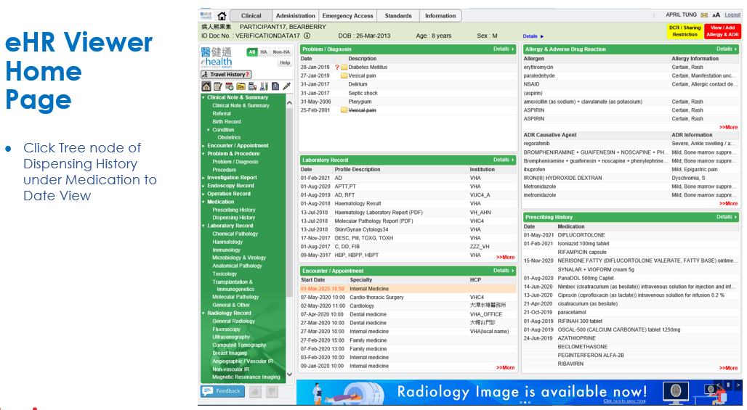
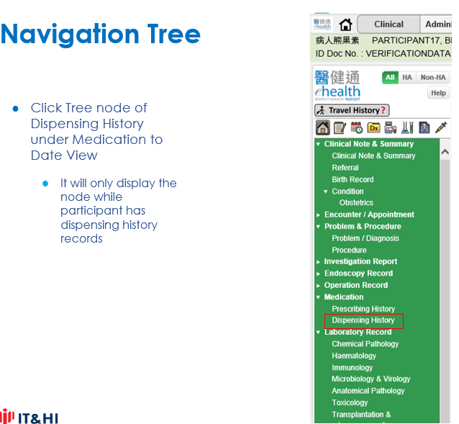
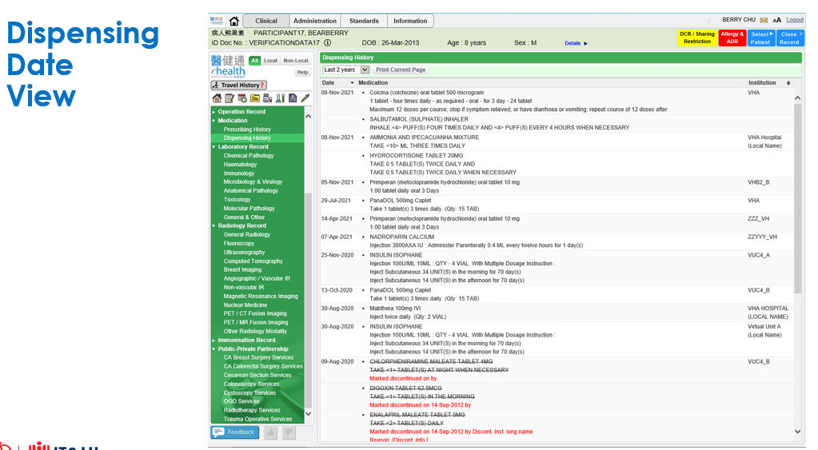
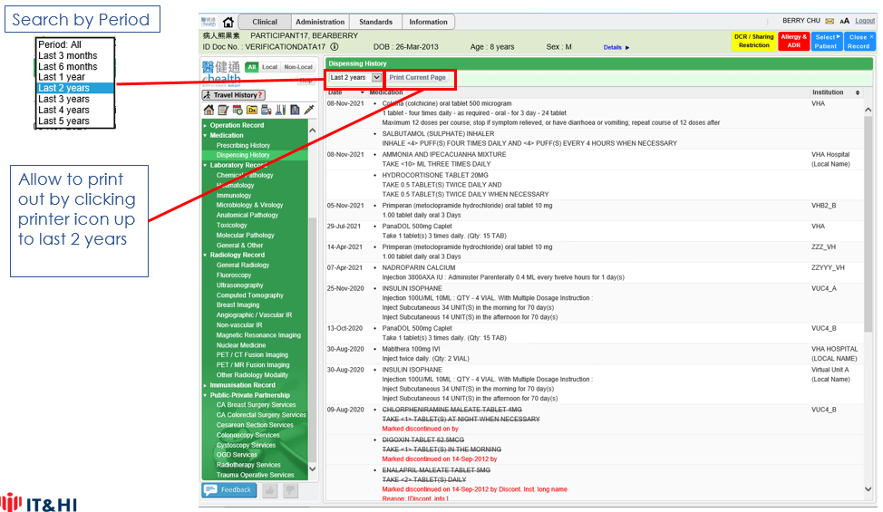
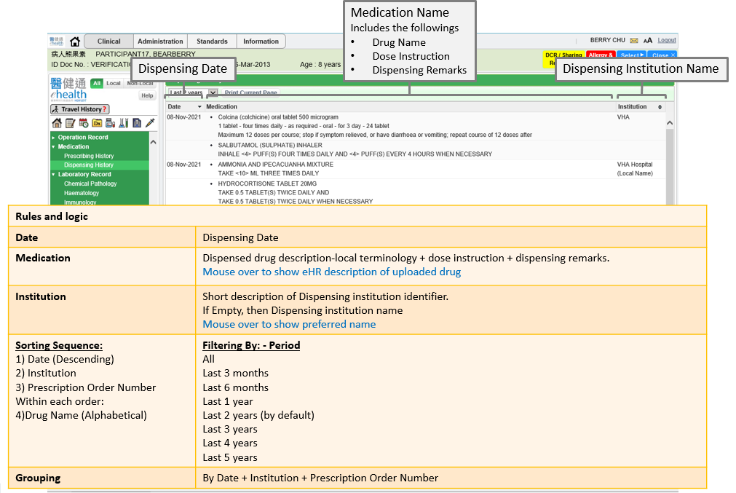
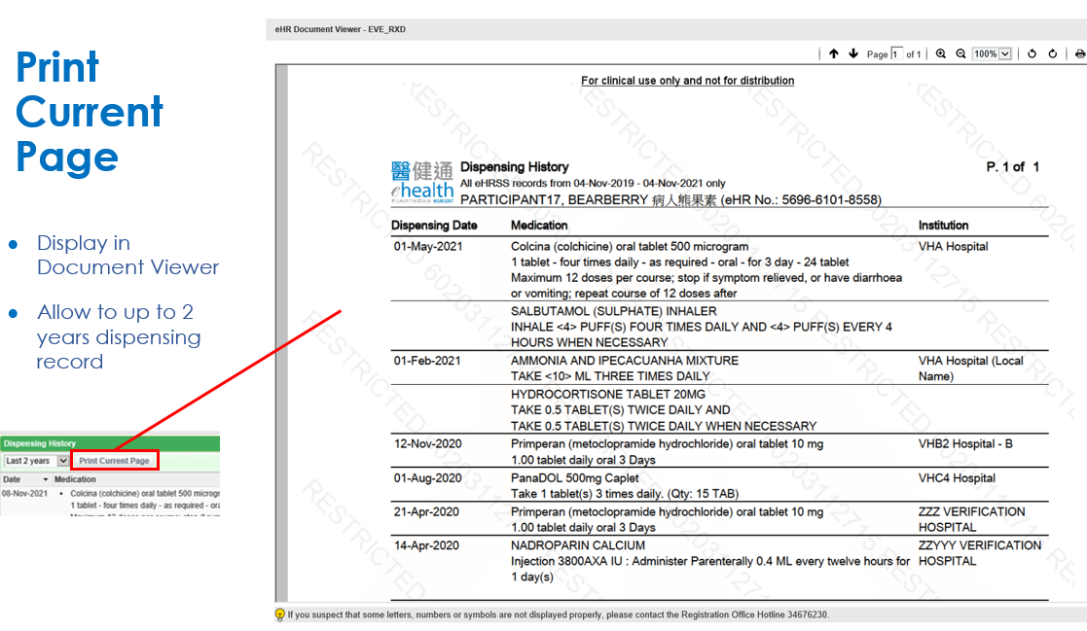
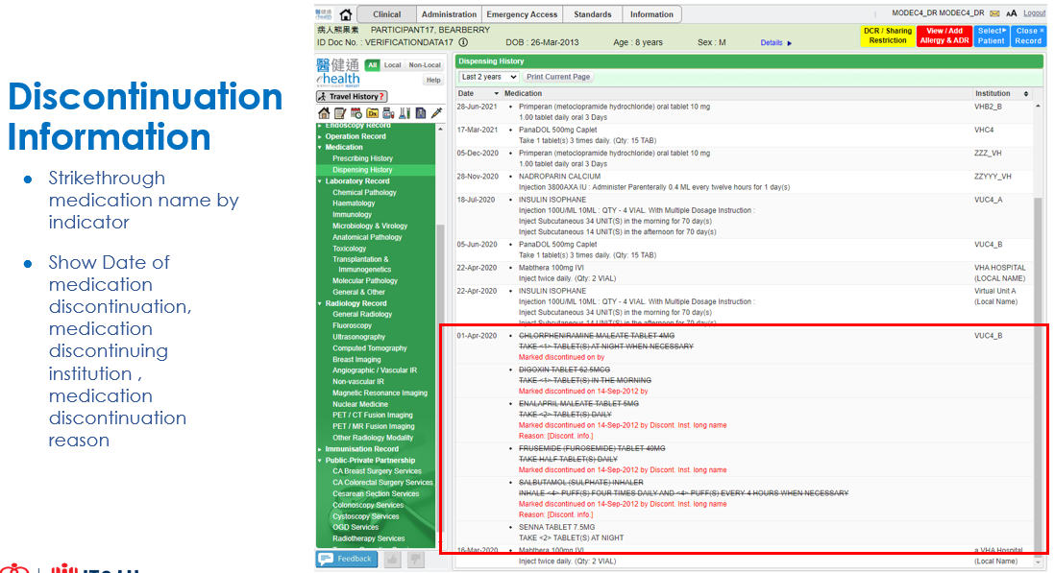

Appendix – Actual Data Values (Sample)

If the actual values entered are various from the test case, please provide actual values as below.
If the value is not inputted, please use [BLANK] to indicate that empty value is inputted intentionally.

